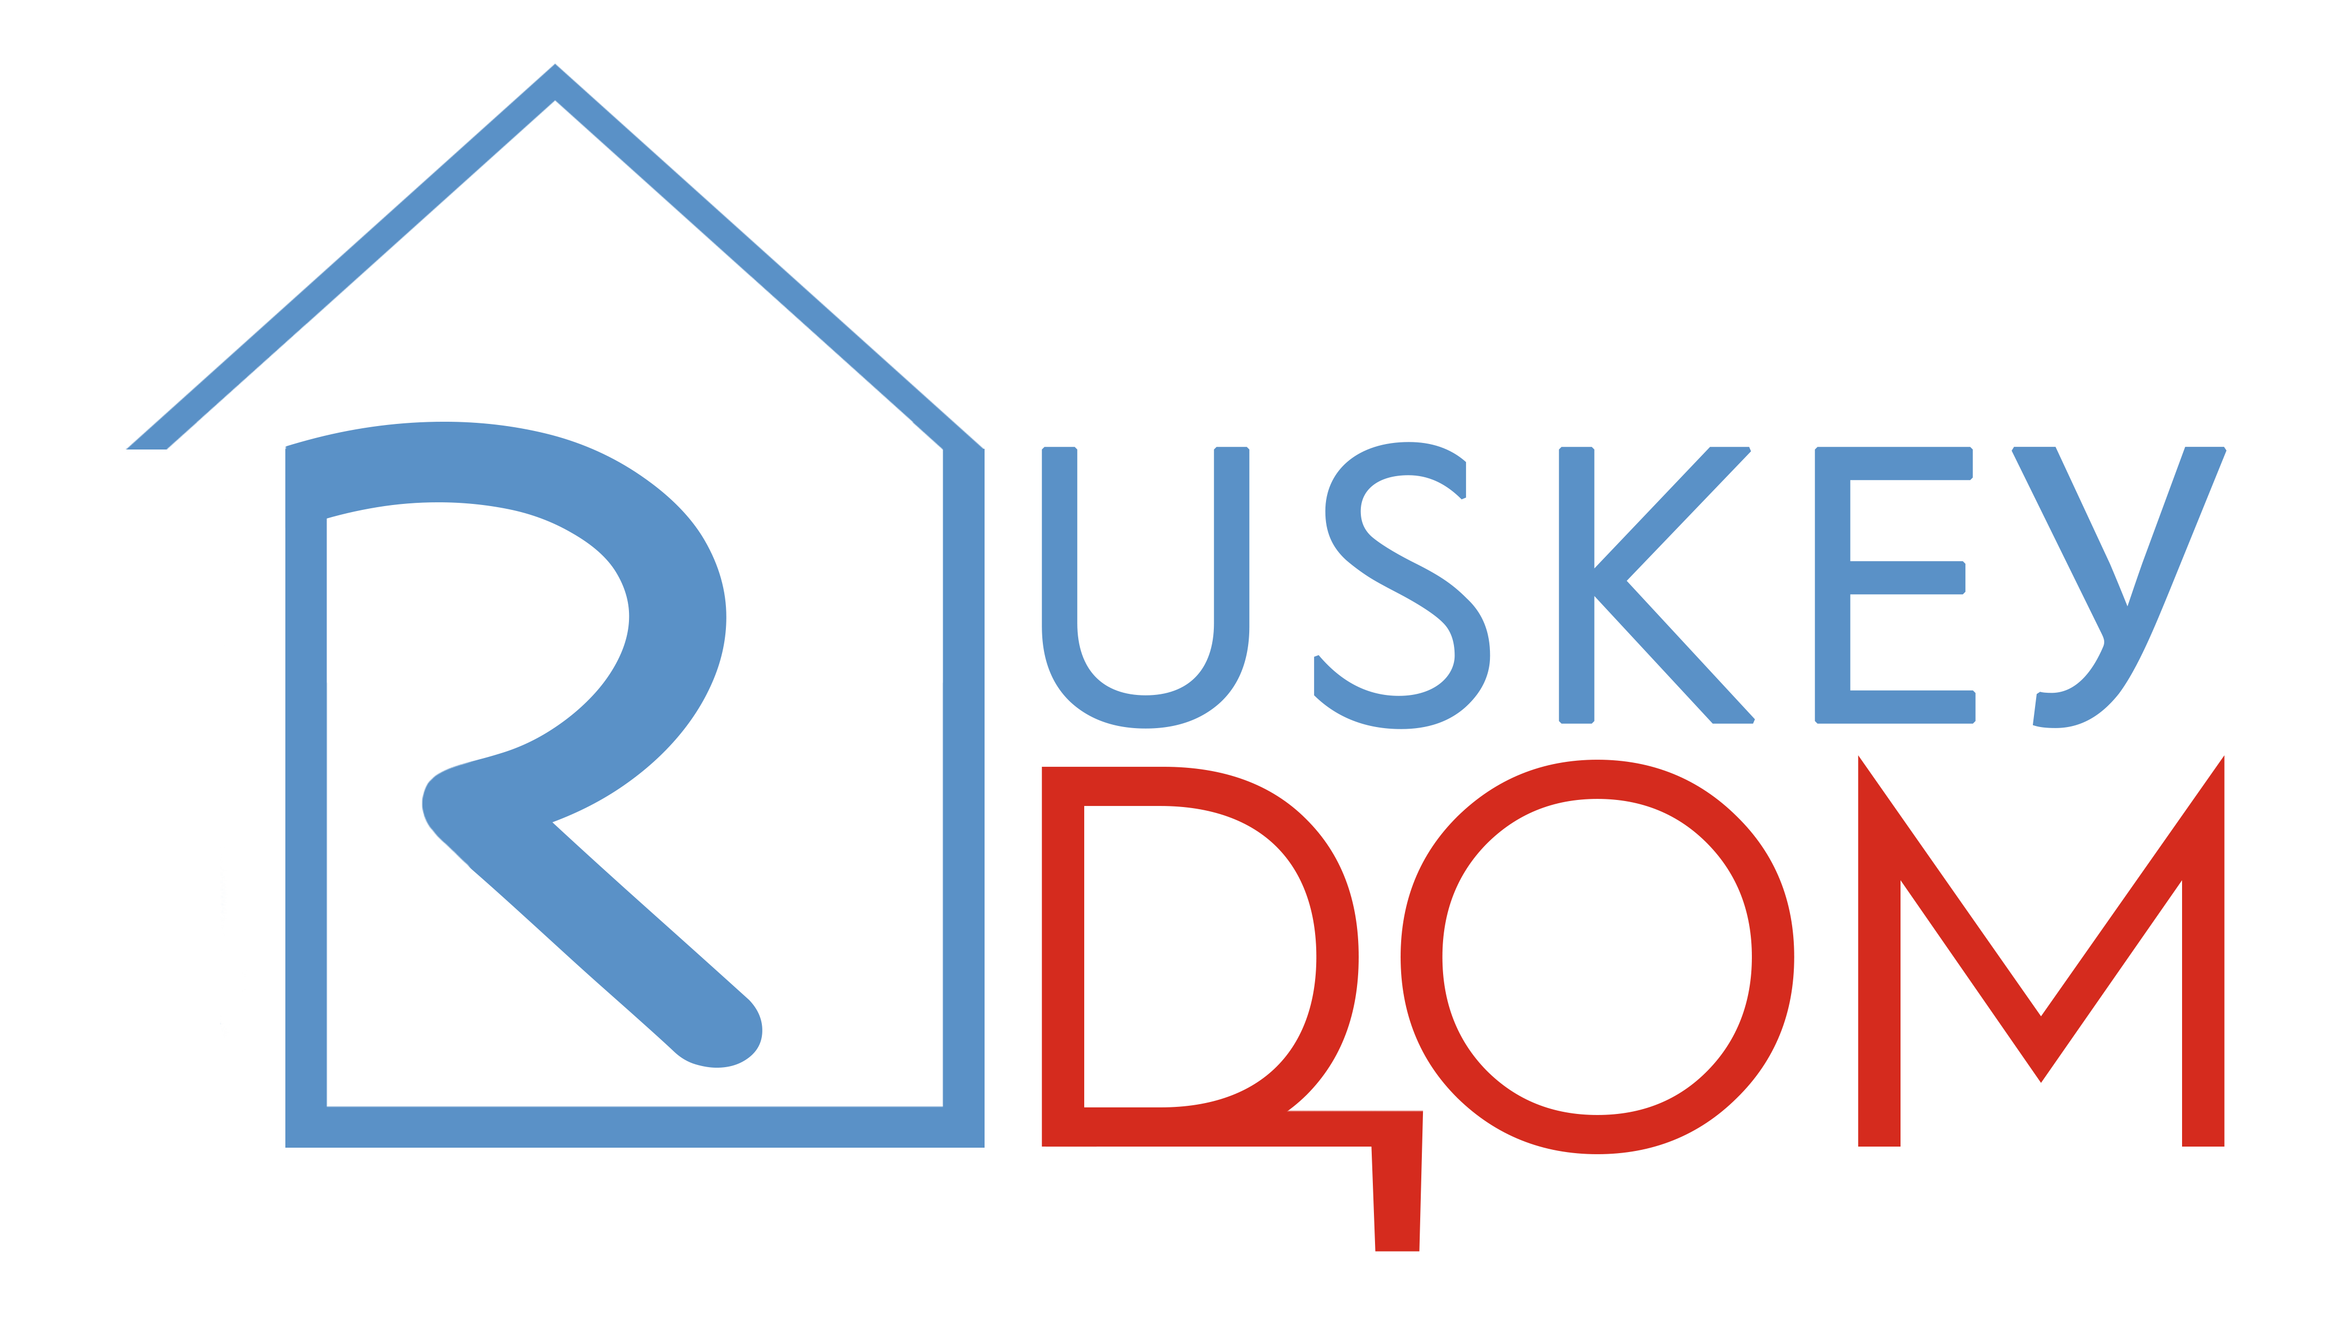
RUSKEY DOM ENROLMENT CONTRACT
For RUSKEY DOM LTD, 20-22 Wenlock Road, London N1 7GU, company no. 13298681
This is a legally binding contract. Please read it carefully.
This Contract is between Ruskey Dom Ltd. (hereinafter the “Education Provider”) and the client (referred to as “Client,” which term includes the singular or plural, as applicable). All persons signing this Contract are jointly and severally liable for the tuition and fees set forth herein. Client’s signature and/or initials on this Contract evidence Client’s understanding and agreement to the terms of this Contract, as follows:
1. Service:
1.1 The Education Provider provides the Client with Educational Services (hereinafter the “Service”, which term includes the singular or plural as applicable) in the study of Russian and Russian-language courses and tours, which the Client agrees to pay the Education Provider for in accordance with the terms of this Contract.
1.2 The Client will be enrolled for all or a portion of the 20_____ - 20_____ academic year
for one or more of the Services (tick as appropriate):
individual education - Russian language
individual education - Cinema Club (online)
individual education - Cinema Club (on premises)
individual education - Online Interpreting and Translation Course
1.3 The Education Provider provides the Client with ______________________________________ which will take place in accordance with a timetable agreed by both Sides.
2. Contractual obligations:
2.1 The Education Provider is required to:
provide qualified Staff that meet the parameters of Services as outlined on ruskeydom.com, printed material produced by the Education Provider, and/or material from social network sites directly related to ruskeydom.com;
2.1.1 provide an effective platform for the carrying out of Services online;
2.1.2 provide an appropriate space for hosting Services on premises;
2.1.3 provide a space that meets current Russian government guidelines on the Covid-19 situation
2.1.4 provide a space free of intimidation, discrimination or harassment in any form towards the Client.
2.2 The Education Provider has the right to:
change the timetable;
2.2.1 refuse the Client the Service if the Service has not been paid for as agreed in this Contract;
2.2.2 refuse the Client entrance if it is evident the Client is ill and could infect others;
2.2.3 refuse the Client entrance at the request of Staff due to inappropriate behaviour online or on premises.
2.3 The Client is required to:
pay for agreed Services on time;
2.3.1 inform the Education Provider at least 12 hours in advance if they cannot attend in order to not forgo any payment made. If a cancellation is made after this time, but 6 hours prior to the start of a lesson, the Client will forgo 50% of the cost of the lesson;
2.3.2 behave appropriately towards Staff and other Clients;
2.3.3 not attend if there are suspicions of illness, particularly Covid-19;
2.3.4 adhere to Education Provider’s demands in connection with Covid-19 situation and Russian government guidelines on aforementioned situation;
2.3.5 inform Education Provider of any changes in personal contact details.
2.4 The Client has the right to:
expect the Education Provider to give accurate and up-to-date information regarding who provides courses, when courses are to take place, price of courses and any changes to courses detailed in this Contract, on ruskeydom.com, in any printed material pertaining to Education Provider, and/or material from social network sites directly related to ruskeydom.com;
2.4.1 to turn to the Educational Provider for help and clarification regarding Services;
2.4.2 ask for classes to compensate for missed Services due to illness, if the possibility exists and the Education Provider is in agreement with the request;
2.4.3 offer services or help to the Education Provider.
3. Payment and forms of payment:
3.1 In accordance with prices detailed on ruskeydom.com, the Client is required to pay _______________ for __________________ which runs from _________ to __________ .
3.2 This payment must be made at least 12 hours prior to the start of Services.
3.3 The Client is required to pay the full amount for Services as detailed in 3.1, unless the Client has agreed otherwise with the Education Provider
3.4 The Client is to pay via one of the agreed forms:
- into Ruskey Dom’s UK bank account
- into Ruskey Dom Ltd PayPal account (email:watt_dan@hotmail.com), using PayPal.Me link, or PayPal QR Code
- into Ruskey Dom Ltd Wise account (email:watt_dan@hotmail.com)
- into a Russian account pertaining to one of the Education Providers’ partners;
3.5 As stipulated in 3.1, the client has agreed to pay in US Dollars, British Pounds, Euros, Russian Roubles (underline as appropriate).
3.6 The Client is obliged to show to the Education Provider visual confirmation that payment has been made. The Client should could keep their own record of payments.
3.7 Due to the instability of the Russian Rouble, the Educational Provider has the right to adjust prices for courses in Russian Roubles in line with the current dollar-rouble exchange rate.
3.8 The Education Provider has the right to increase prices on Services, of which the Client must be informed 14 days prior to the beginning of a new course and the signing of a new Contract. This increase can come into effect during the appropriate academic year, but cannot be implemented after the signing of this Contract and the stipulation of dates given in 3.1.
3.9 The Education Provider has the right to terminate this Contract without the return of any form of payment due to inappropriate, offensive or dangerous behaviour on the part of the Client towards the Education Provider, its Staff and/or other Clients.
4 Abrupt termination of Contract:
4.1 The Education Provider has the right to terminate this Contract prior to the termination date if there is an infringement of the Contract, namely:
failure to pay on time for Services;
4.1.1 damage to the premises caused by Client’s action;
4.1.2 Inappropriate, offensive or dangerous behaviour on the part of the Client towards the Education Provider, its staff and/or other Clients;
4.1.3 any infringements deemed illegal under Russian legislation.
4.2 The Client has the right to terminate this Contract prior to the termination date:
4.2.1 of their own free will;
4.2.2 failure of the Education Provider to meet Contractual obligations;
4.2.3 any infringements deemed illegal under Russian legislation.
4.3 If either 4.2.2 or 4.2.3 are agreed on in a house of law, the Education Provider is required to return the payment made by the Client in full.
4.4 Termination by either side is final.
5 Other Conditions:
5.1 The Education Provider reserves the right to change Staff, as well as cancel classes, courses or tours due to the illness of Staff.
5.2 Should a class or classes be cancelled as a result of Staff illness, the Education Provider is obliged to make up for the missed class or classes. The date and time should be agreed with the Client.
5.3 The Education Provider’s duties and obligations under this Contract shall be suspended immediately without notice during all periods that the School is closed because of force majeure events including, but not limited to, any fire, act of God, hurricane, war, governmental action, act of terrorism, epidemic, pandemic, or any other event beyond the Education Provider’s control. If such an event occurs, the Education Provider’s duties and obligations in this Contract will be postponed until such time as the Education Provider, in its sole discretion, may safely reopen. In the event that the Education Provider cannot reopen due to an event under this clause, the Education Provider is under no obligation to refund any portion of the tuition paid.

5.4 The Client agrees to allow for their name, photograph, voice, image, and information to be used by the Education Provider for use in publications, promotion materials, social networks, and website, without compensation and without prior notice.
5.5 This Contract is available on ruskeydom.com, via email, or any other format suitable for the Client.
6 Length of contract:
6.1 This contract is effective from _______________ to _______________. The dates have been agreed by both Sides.
I _______________________________________________________ (name and signature) agree to the terms and conditions of this Contract.

